SMART CAMPUS PLACEMENT SYSTEM
Design and Implementation
Department of Computer Science and Engineering, TKR College of Engineering & Technology
Batch C5 (CSE-C) · Academic year [ACADEMIC YEAR]
Table 1: Project team
S.No. | Student name | Roll number
1 | Mopidevi Bhagyasri | 23K91A05F9
2 | Pamulaparthi Harsha Vardan Reddy | 23K91A05J0
3 | Mohammad Faruk Baba | 23K91A05F3
4 | Prahalladh Terati | 23K91A05J8

Project guide: S Usha Devi
Chapter and section numbers quoted in the text (for example Chapter 8 or Section 6.2) refer to the full project report, 17.Final Document. Figures and tables in this document are numbered from 1.

1. DESIGN

1.1 Design goals
The design follows from the requirements of Chapter 4. It must (i) give one prediction function that every interface uses, so that the Flask pages, the JSON API and the React application always agree; (ii) run on one ordinary Windows PC without a GPU or a database server; (iii) answer a single prediction in well under a second; (iv) tell the student not only a probability but the specific gaps behind it; and (v) leave the original Flask application working, so that the new interface is an addition rather than a rewrite.
• Reuse over rewrite. backend/main.py contains no model logic; every endpoint calls predict_for, recommend or pre_comp_cache from src/recommend.py, or reads the same files as the Flask app.
• Files instead of a database. The data are two small read-only tables and a few model files; a database server would add a dependency without a capability.
• Validate at the edge, explain the result. Pydantic ranges give 422, an unknown company 404, a missing model 503; the result carries the cutoff comparison and tips, and the dashboard the SHAP ranking.

1.2 System architecture
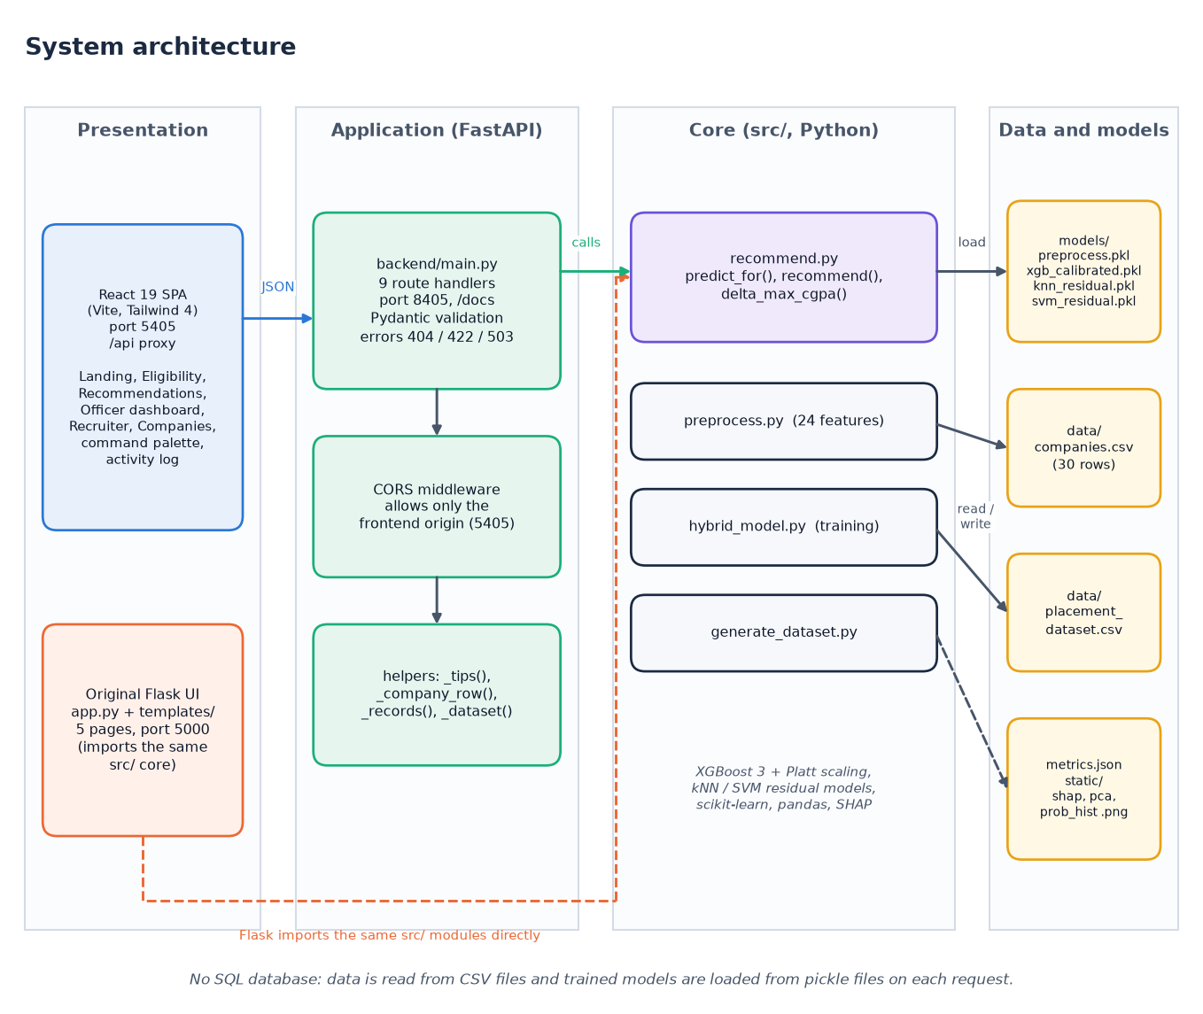
Figure 1: System architecture of the Smart Campus Placement System: presentation, application and core layers with the file stores.
The system has four columns. The presentation column holds the React 19 single-page application (Vite, Tailwind 4, port 5405) and the original Flask pages (app.py and five templates, port 5000). The application column is the FastAPI service backend/main.py (port 8405): nine route handlers, Pydantic validation, a CORS rule that admits only the front-end origin and a few helpers (_tips, _company_row, _records, _dataset). The core column is the src/ package: recommend.py serves predictions and recommendations, preprocess.py builds the 24 features, hybrid_model.py trains and evaluates, generate_dataset.py writes the synthetic data. The data column holds the two CSV tables, the five pickled model files with metrics.json, and three plot images. The FastAPI layer contains no model logic: it imports predict_for, recommend and pre_comp_cache from src/recommend.py, which is the same code the Flask app calls, so the two interfaces cannot drift apart. There is no SQL database; the pickled models are read from disk on each request.
The contract between browser and server is narrow: JSON in both directions. In development the Vite server proxies /api to port 8405, so the interface never needs to know the API address and CORS is not exercised; the API nevertheless allows the two front-end origins (localhost:5405 and 127.0.0.1:5405) and no others.

1.3 High-level workflow
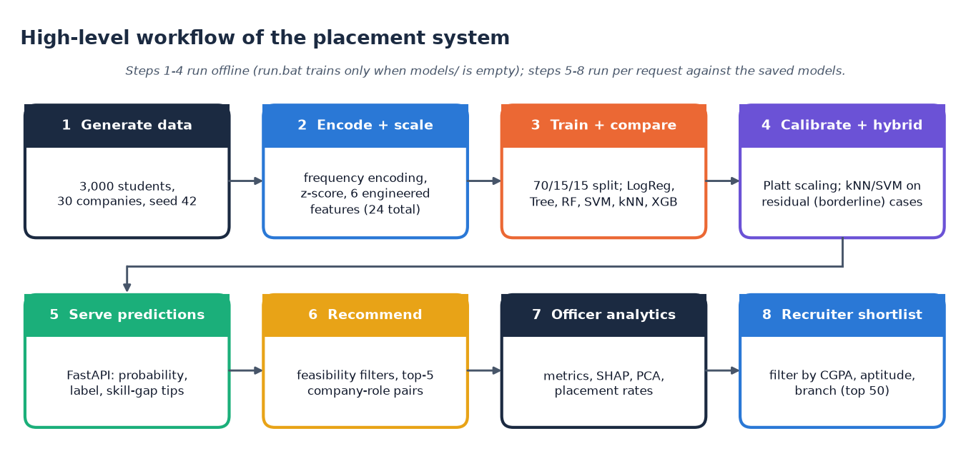
Figure 2: High-level workflow from data generation to recruiter shortlist.
Training (data generation, encoding, split, calibration, residual models) runs offline; every request then loads the saved models. run.bat retrains only when the model files are missing.

1.4 Data flow diagrams

1.4.1 Level 0
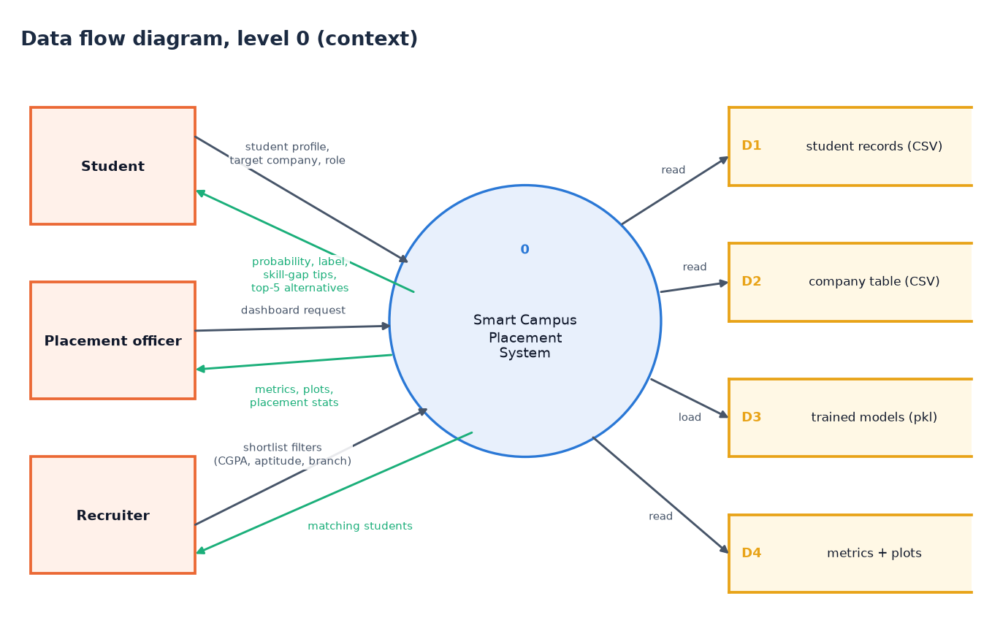
Figure 3: Level 0 data flow diagram: the system as one process with three external entities and four data stores.
A student, a placement officer and a recruiter exchange profiles, filters and results with one process that only reads four stores: student records (D1), companies (D2), models (D3), metrics and plots (D4).

1.4.2 Level 1
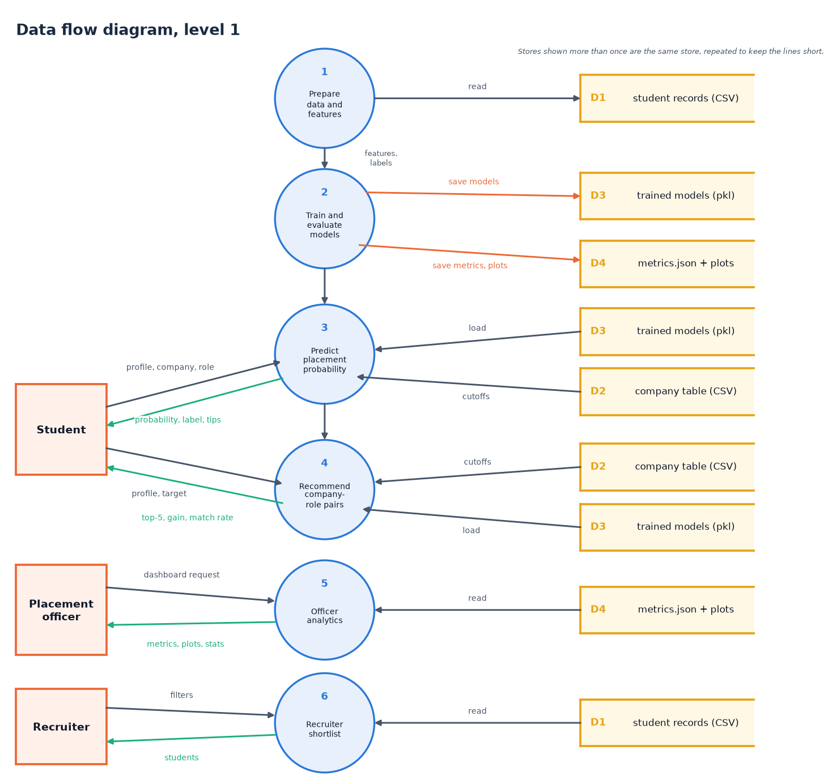
Figure 4: Level 1 data flow diagram: six processes, three external entities and four data stores.
Processes 1 and 2 (prepare data, train and evaluate) run offline; processes 3 to 6 (predict, recommend, officer analytics, recruiter shortlist) run per request. Repeated stores are the same store.

1.4.3 Level 2: recommending company-role pairs
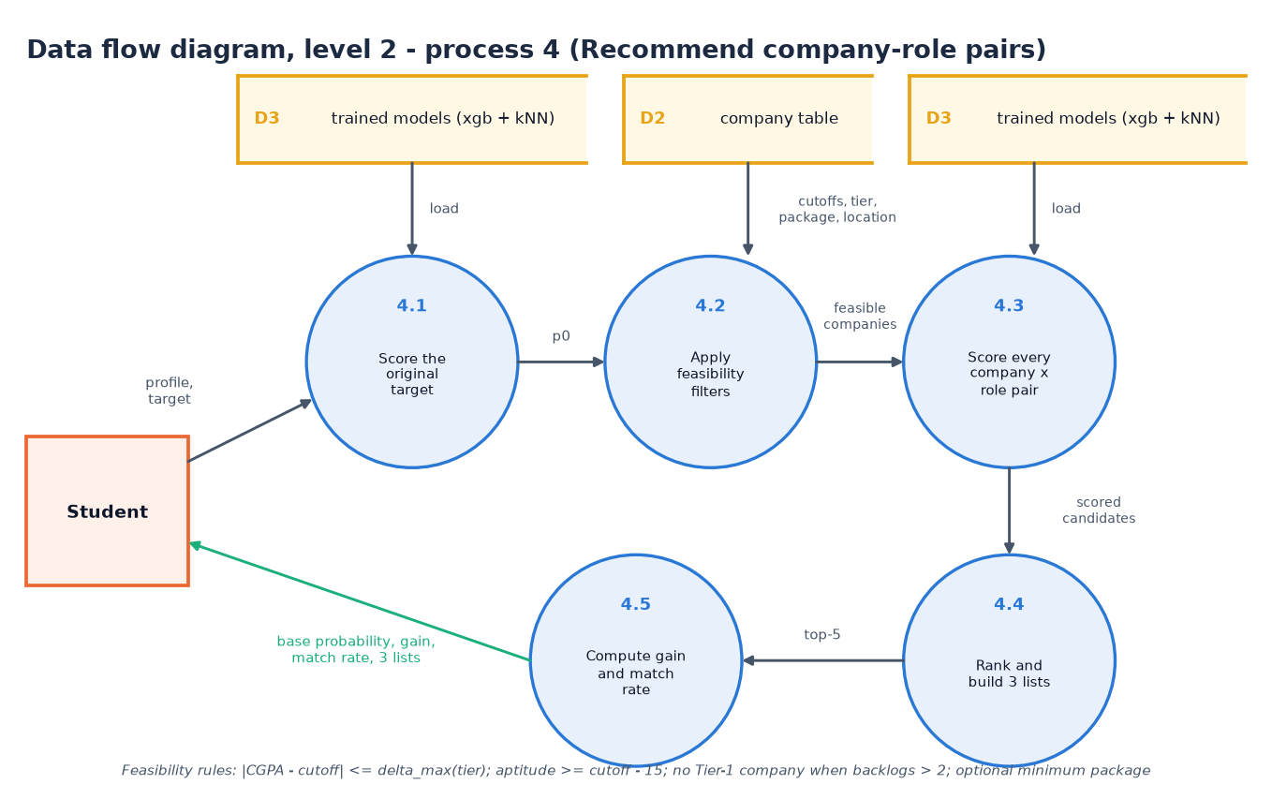
Figure 5: Level 2 data flow diagram of process 4, Recommend company-role pairs.
Process 4 is the most complex request, so it is decomposed. 4.1 scores the student's original target to obtain the base probability p0. 4.2 applies the feasibility filters to the 30 companies: the CGPA gap must not exceed delta_max of the company tier, aptitude must be at least the cutoff minus 15, a student with more than two backlogs is not offered Tier-1 companies, and an optional minimum package is honoured. 4.3 scores every feasible company with four roles (the target role, SDE, Data Analyst, QA Engineer). 4.4 ranks the candidates by score and builds the three lists, and 4.5 computes the average gain and the match rate. The trained models (D3) are read by 4.1 and 4.3, the company table (D2) by 4.2.

1.5 UML diagrams

1.5.1 Class diagram
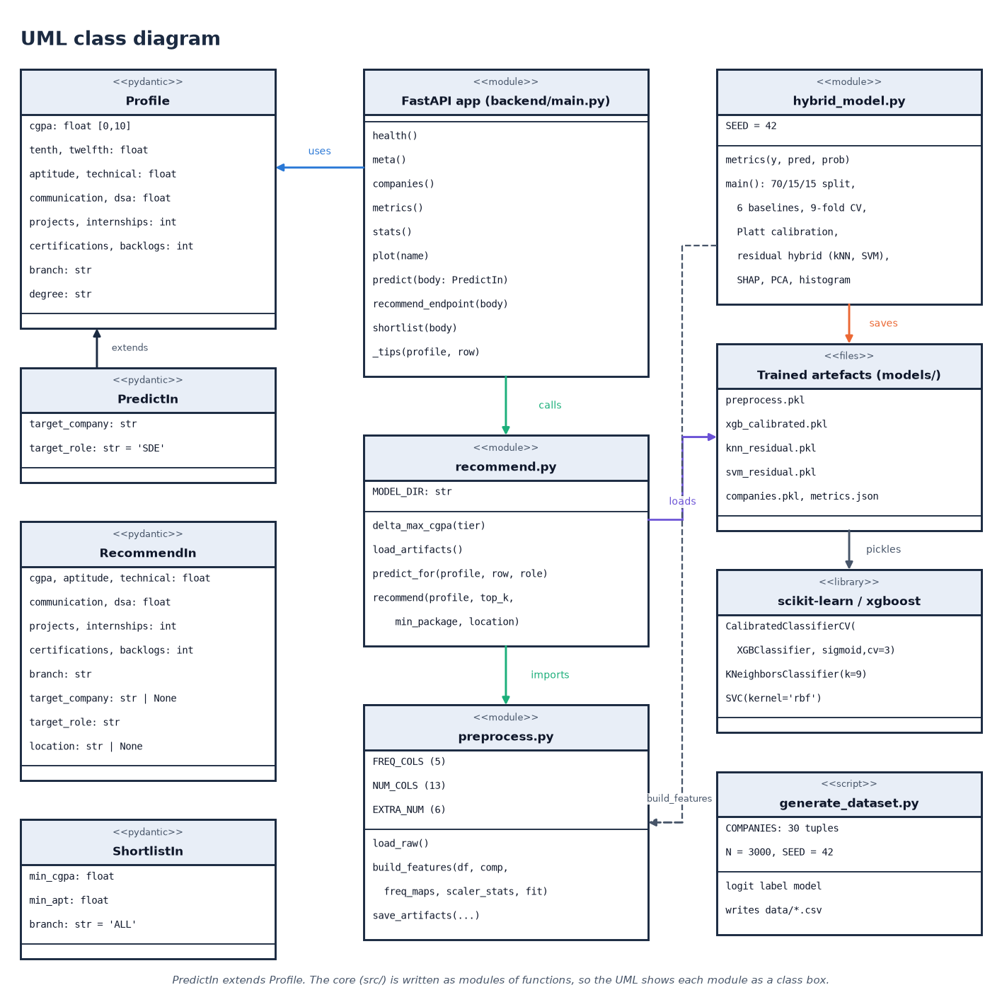
Figure 6: UML class diagram: request models, API module, core modules and the trained artefacts.
The code is modules of functions plus four Pydantic classes, so modules are drawn as class boxes; PredictIn extends Profile, the API calls recommend.py, which imports preprocess.py and loads the pickled artefacts.

1.5.2 Sequence diagram
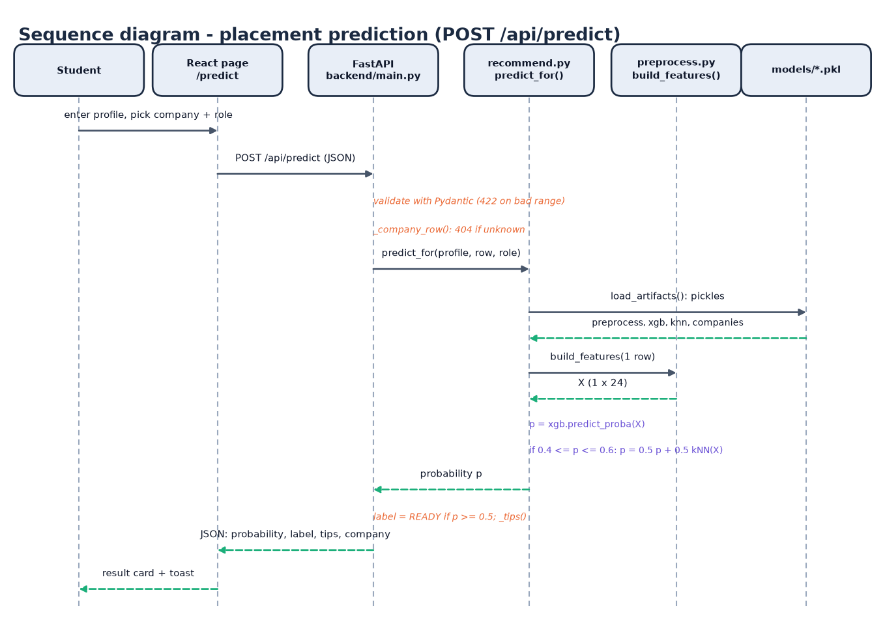
Figure 7: Sequence diagram of POST /api/predict, the main flow of the system.
The student enters a profile on the Eligibility page and picks a company and a role. The page posts JSON to /api/predict. FastAPI validates the body with Pydantic (422 on a bad range) and looks the company up (404 if unknown). predict_for loads the four pickles, build_features turns the single row into a 1 x 24 vector, the calibrated XGBoost model gives a probability and, when the probability lies between 0.4 and 0.6, it is averaged with the kNN probability. The endpoint labels the result PLACEMENT READY at 0.5 or above, adds the skill-gap tips and returns JSON; the page shows a result card and a toast.

1.5.3 Use-case diagram
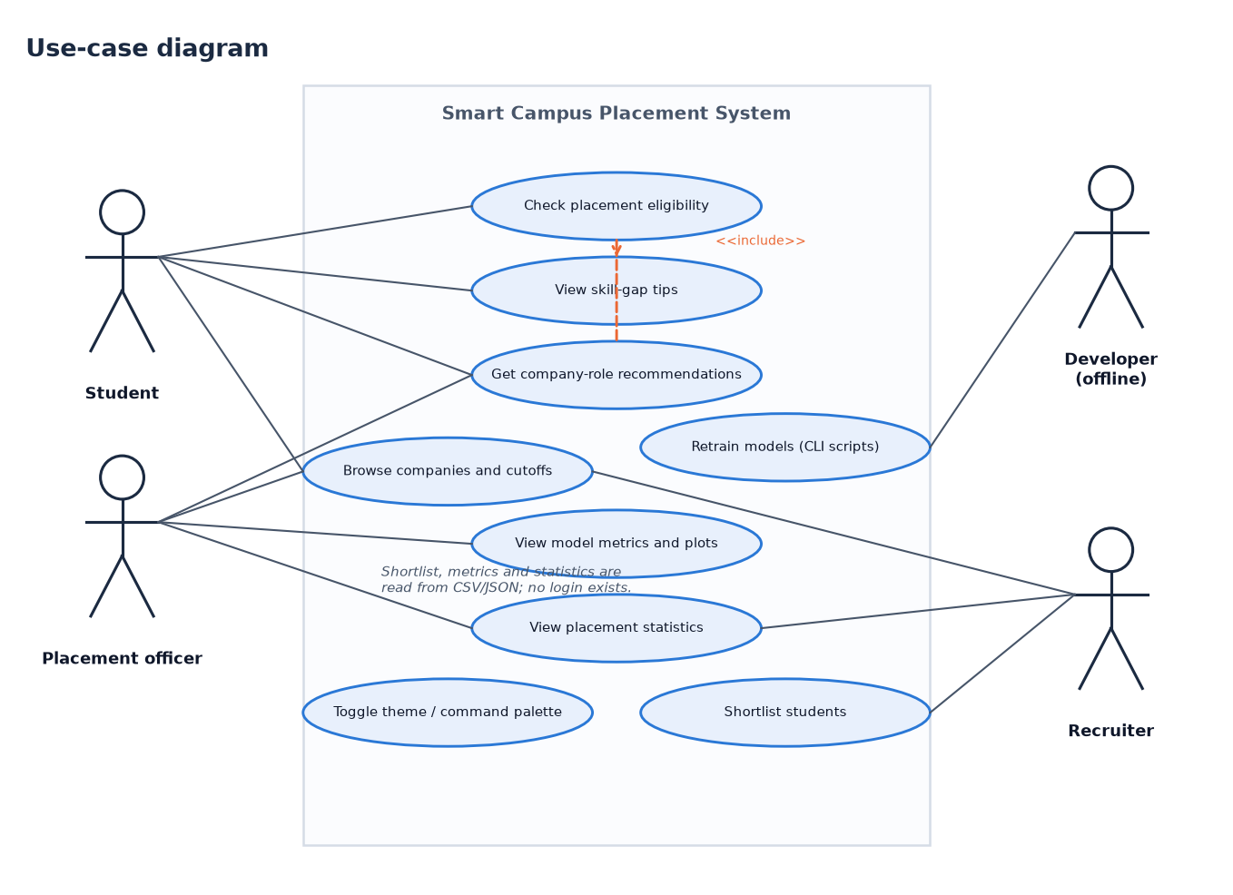
Figure 8: Use-case diagram with three user roles and one offline developer role.
Students check eligibility, read tips and get recommendations; officers view metrics, plots and statistics; recruiters shortlist students. The developer role is offline (retraining scripts). There is no login.

1.6 Database design
A design chapter normally describes a database, so we state it plainly: this system has no SQL database. The batch description mentions MySQL, but the implemented system stores its data in files, for three reasons. The data are two small tables (3,000 and 30 rows) that are never modified while the application runs; the models are pickles that must be loaded as a whole; and the users are anonymous, so there are no accounts to store. The logical data model is therefore described by the data dictionary below and drawn as an entity-relationship diagram. Moving to MySQL would be a natural extension (Chapter 10).
Table 2: Data dictionary of data/placement_dataset.csv (3,000 rows, 19 columns, no missing values)
Column | Type | Observed range | Meaning
CGPA | float | 5.80 - 9.35 | Cumulative grade point average out of 10
Tenth_Percent | float | 45.0 - 93.8 | Class 10 percentage
Twelfth_Percent | float | 40.3 - 89.2 | Class 12 percentage
Aptitude_Score | float | 27.6 - 98.0 | Quantitative and logical aptitude test score
Technical_Score | float | 26.2 - 100 | Technical (core subject) test score
Communication_Score | float | 20.0 - 90.6 | Communication assessment score
DSA_Score | float | 10.0 - 100 | Data-structures and algorithms assessment score
Projects, Internships, Certifications | int | 0-6, 0-4, 0-6 | Counts of completed projects, internships and certifications
Backlogs | int | 0 - 4 | Number of failed subjects still pending
Branch | text | 6 values | CSE, IT, ECE, EEE, MECH, CIVIL
Degree_Type, Student_Type | text | 2 + 2 values | BTech / MTech; Regular / Lateral entry
Placement_Year | int | 2023 - 2026 | Year of the placement season
Target_Company | text (FK) | 30 values | Company the student applied to; must exist in companies.csv
Target_Role | text | 8 values | SDE, Data Analyst, ML Engineer, QA Engineer, DevOps, Support Engineer, Embedded Engineer, Design Engineer
Target_Tier | int | 1, 2, 3 | Tier of the target company (copied from the company table)
Placed | int (label) | 0 / 1 | 1 = placed (1,791 rows, 59.7%), 0 = not placed (1,209 rows)

Table 3: Data dictionary of data/companies.csv (30 rows, 9 columns)
Column | Type | Observed range | Meaning
Company | text (PK) | 30 names | Company name, for example Google, Infosys, L&T
Tier | int | 1, 2, 3 | 1 = dream (7 companies), 2 = core (15), 3 = mass recruiter (8)
CGPA_Cutoff | float | 6.0 - 8.5 | Minimum CGPA the company usually asks for
Apt_Cutoff, Tech_Cutoff | int | 55 - 85, 50 - 85 | Aptitude and technical score cutoffs
Package_LPA | float | 4.0 - 28.0 | Offered package in lakhs per annum
Location | text | 7 values | Bangalore, Hyderabad, Chennai, Pune, Mumbai, Noida, Mysore
Company_Type | text | 3 values | MNC, Startup, Core
Hiring_Rate | float | 0.12 - 0.55 | Share of applicants normally hired; lower for dream companies

Both tables are synthetic: the student records were generated by src/generate_dataset.py and the company values are plausible but invented, not real recruiter requirements. Section 6.2 describes the generator.
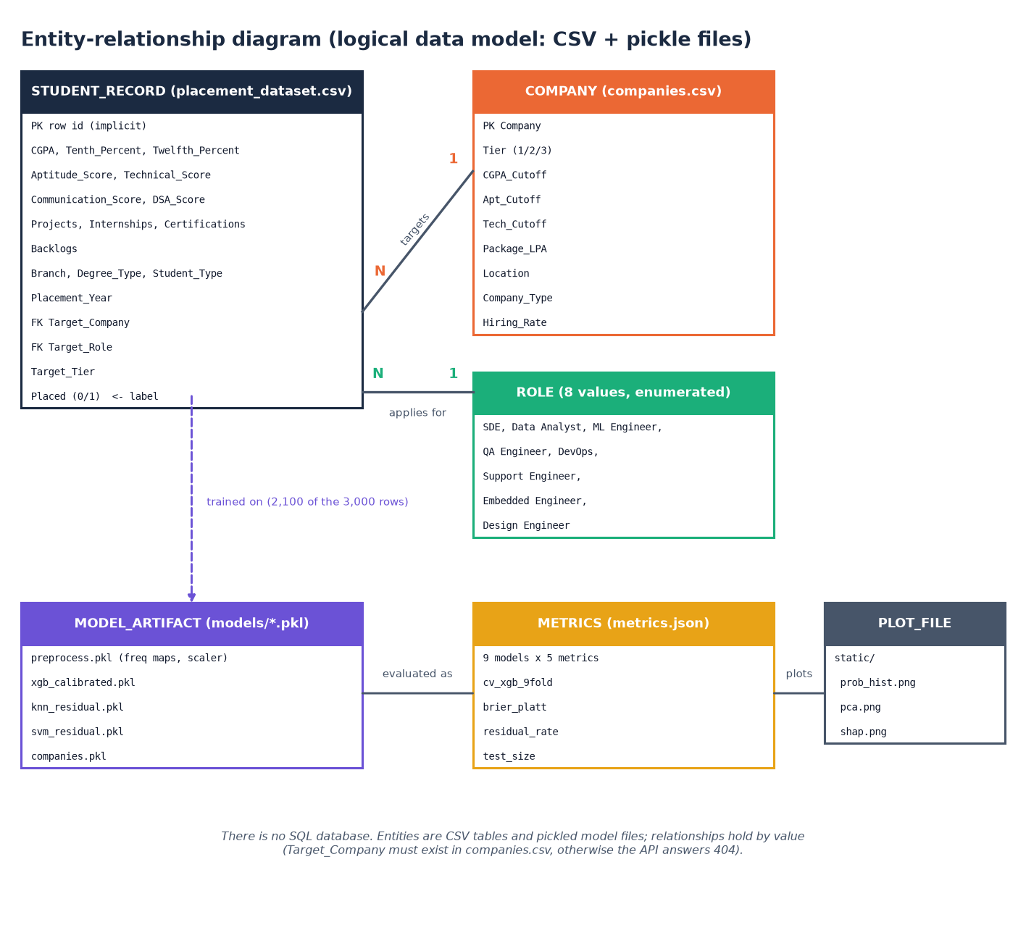
Figure 9: Entity-relationship diagram of the logical data model (CSV and pickle files).
Persistent files: the two CSV tables (277 KB and 1.4 KB), five pickles in models/ (xgb_calibrated 1.49 MB, knn_residual 0.42 MB, svm_residual 0.20 MB, preprocess 2.7 KB, companies 4.3 KB), metrics.json and three PNG plots in static/.

1.7 Module design
The table below lists the modules with their sizes (lines, measured with wc -l) and responsibilities. The training and serving core is small: 508 lines in four files. The API layer is 221 lines, the original Flask application 140 lines plus five templates, and the React interface about 3,000 lines of JavaScript.
Table 4: Module breakdown
Module | Lines | Responsibility | Key names
src/generate_dataset.py | 121 | Company table (30 tuples), synthetic students and the logit label model; writes data/*.csv | COMPANIES, SEED = 42
src/preprocess.py | 69 | Frequency encoding, z-score, six engineered features; saves preprocess.pkl | build_features, load_raw
src/hybrid_model.py | 186 | Split, six baselines, 9-fold CV, Platt calibration, residual hybrid, SHAP/PCA/histogram plots | main, metrics
src/recommend.py | 132 | Single-row features, calibrated probability with kNN blend, feasibility filters, three recommendation lists | predict_for, recommend, delta_max_cgpa
backend/main.py | 221 | Nine FastAPI endpoints, Pydantic models, CORS, tips, error mapping | predict, recommend_endpoint, shortlist
app.py + templates/ + static/style.css | 140 + 99 + 12 | Original Flask interface: five pages and POST /api/predict | predict, recommend_page, dashboard
frontend/src | 3,017 | Six React pages, UI kit, charts, three.js backdrop, activity log, command palette | Predict.jsx, Recommend.jsx, api.js
scripts/ | 1,256 | Smoke test, edge tests, experiments, diagrams and screenshot capture written or kept for this work | smoke_test.py, edge_tests.py
run.bat | 70 | Creates .venv, installs packages, trains if needed, installs npm packages, starts both servers | -

Dependencies run in one direction only: interfaces call src/recommend.py, which calls src/preprocess.py; the training script uses preprocess.py and writes the files that recommend.py loads. No module in src/ imports Flask, FastAPI or React.

1.8 Algorithm design

1.8.1 Hybrid prediction
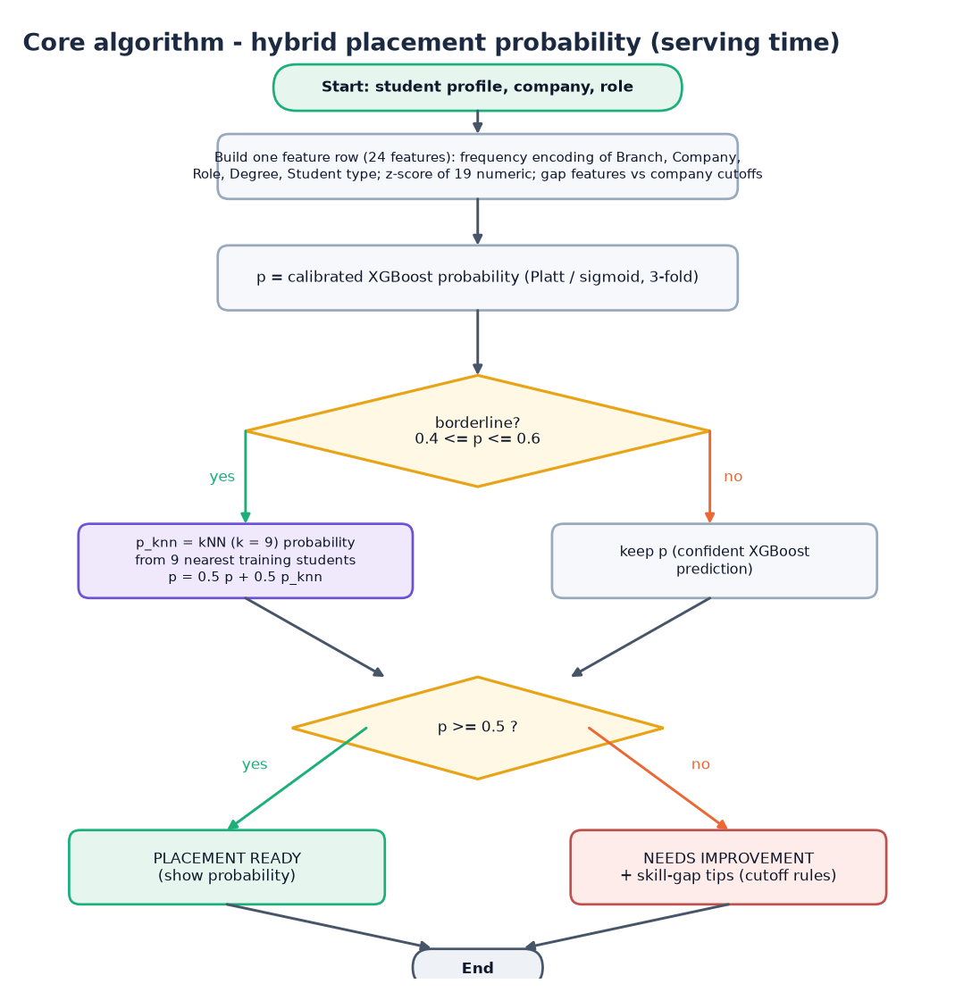
Figure 10: Flowchart of the hybrid placement probability computed at serving time.
A 24-value feature row gives the calibrated XGBoost probability p; if 0.4 <= p <= 0.6 it is averaged with the kNN probability; p >= 0.5 is labelled PLACEMENT READY, otherwise NEEDS IMPROVEMENT with tips.

1.8.2 Training pipeline
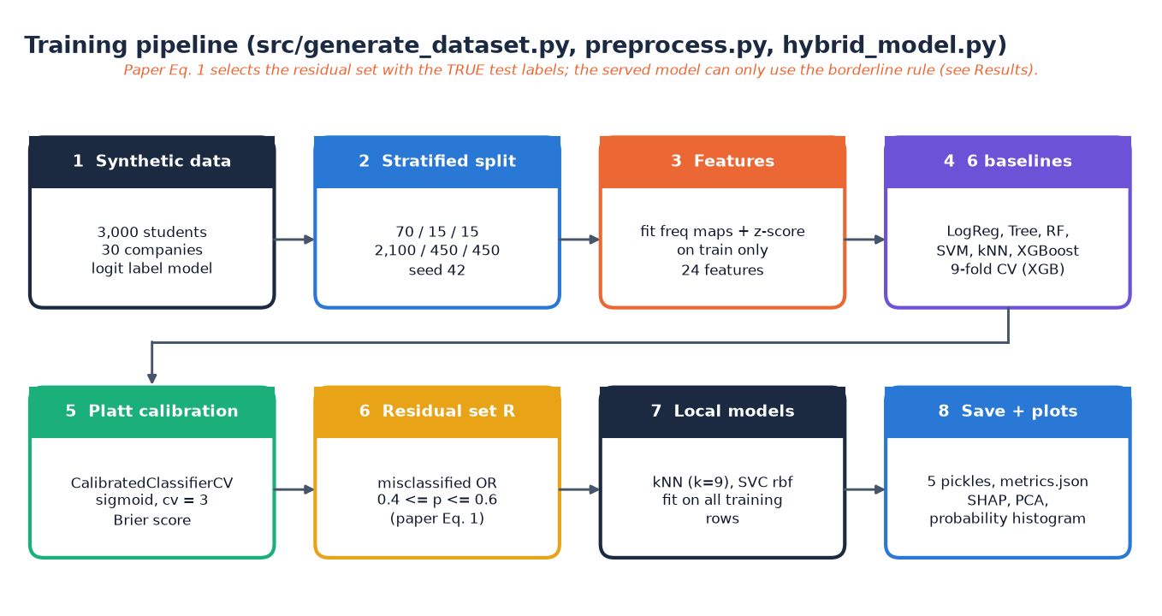
Figure 11: Training pipeline of src/generate_dataset.py, preprocess.py and hybrid_model.py.
The residual set of Equation 1 in the technique paper [2] uses the true labels of the evaluated rows, which a deployed system does not have (Section 6.6).

1.8.3 Recommendation
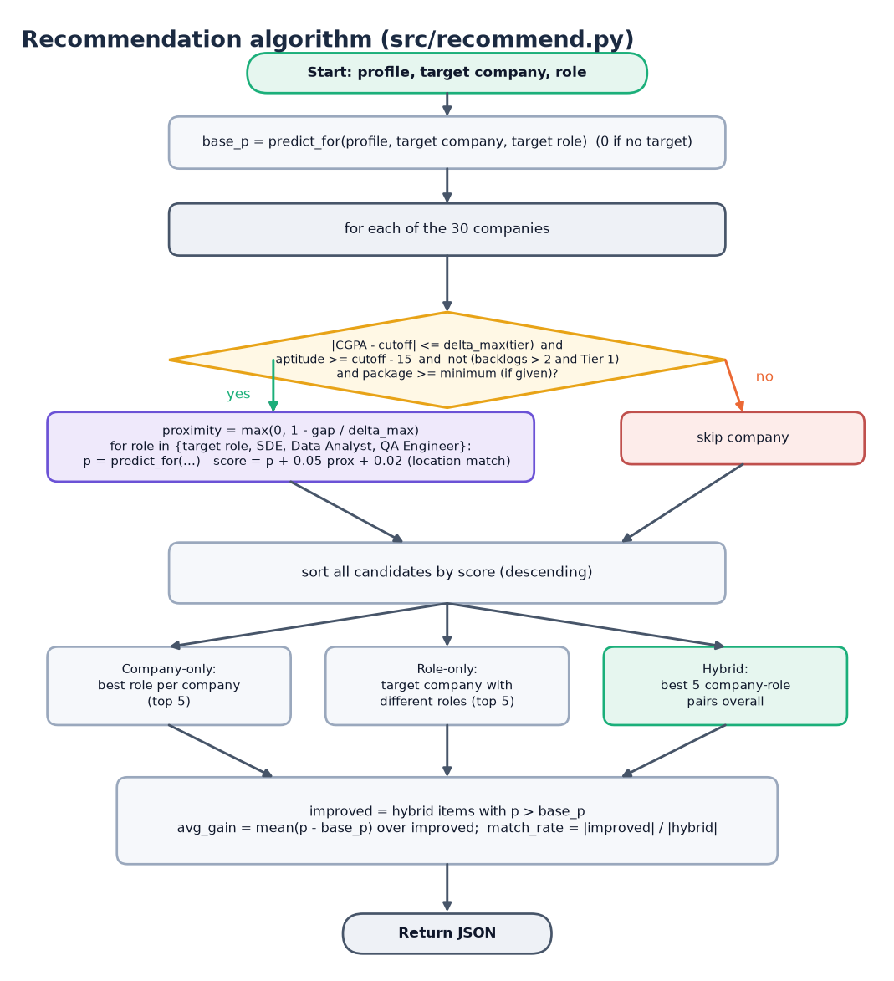
Figure 12: Flowchart of recommend() in src/recommend.py.
Each feasible company is scored for four roles with score = p + 0.05 x proximity + 0.02 x location bonus; the sorted candidates give the company-only, role-only and hybrid lists, and the gain and match rate are computed over hybrid items that beat the base probability.
Three design choices deserve a reason. The probability is calibrated (Platt scaling) because the recommender ranks companies by probability and a ranking is only meaningful if probabilities are comparable [4, 9]. The local model is applied only in the borderline band, where the global model is least certain [2]. The recommender is filtered before it is scored, so that it never suggests a company whose CGPA requirement is far from the student's or a Tier-1 company for a student with more than two backlogs.

1.9 API design
The nine endpoints below are the whole server interface; the interactive documentation is generated at /docs by FastAPI. Request bodies use Pydantic models, so type and range errors are reported per field.
Table 5: Endpoints of backend/main.py
Method | Path | Request and response | Errors
GET | /api/health | status, models_ready (true when all four model files exist) | -
GET | /api/meta | branches (6), degrees (2), predict_roles (6), recommend_roles (4), locations (6), companies (30 names) | -
GET | /api/companies | All 30 company rows: Company, Tier, CGPA_Cutoff, Apt_Cutoff, Tech_Cutoff, Package_LPA, Location, Company_Type, Hiring_Rate | -
GET | /api/metrics | Content of models/metrics.json: results per model, cv_xgb_9fold, brier_platt, residual_rate, test_size | 503 file missing
GET | /api/stats | total, placed_rate, avg_cgpa, by_branch placed rates | 503 dataset missing
GET | /api/plots/{name} | PNG of prob_hist, pca or shap | 404 other name or file missing
POST | /api/predict | In: profile (11 numbers, branch, degree) + target_company + target_role. Out: placement_probability, eligible, label, company, role, company_detail, tips | 404 unknown company, 422 out of range or wrong type
POST | /api/recommend | In: 9 numbers, branch, optional target_company, target_role, location. Out: base_prob, company_only, role_only, hybrid, avg_gain, match_rate | 404 unknown company, 422
POST | /api/recruiter/shortlist | In: min_cgpa, min_apt, branch (or ALL). Out: total_matches, students (at most 50, sorted by CGPA then Technical_Score) | 422 out of range

Two request models are shared: Profile (cgpa 0-10, tenth, twelfth, aptitude, technical, communication, dsa 0-100, projects, internships, certifications, backlogs 0-20, branch, degree) is extended by PredictIn with a company and a role; RecommendIn repeats the numeric fields without tenth, twelfth and degree and makes the company, role and location optional; ShortlistIn carries min_cgpa, min_apt and branch.

1.10 User interface design
The React interface was rebuilt on the Kinetic Mono design kit (version 5): a terminal-inspired look with a monospaced accent font, a dark theme by default and a light theme, a navigation sidebar on desktop that becomes a drawer on small screens, and a slowly moving wire-grid backdrop drawn with three.js. The kit was adapted to this project: the API client, the formatting helpers, the activity log and the chart components were written for the placement data, and the three.js scene falls back to a plain background when WebGL is unavailable or the user prefers reduced motion.
Table 6: Screens of the React application
Screen | Route | Content
Landing | / | Animated hero, live counters, terminal-style log, three.js wire grid, model table and company marquee
Eligibility | /predict | Profile form, company and role pickers, probability, label, cutoff comparison, skill-gap tips
Recommendations | /recommend | Profile form, base probability, average gain, match rate, top pick, chart and three ranked lists
Officer dashboard | /dashboard | Four KPI tiles, model comparison chart, placed rate by branch, tabs: model table, SHAP, PCA, probabilities
Recruiter | /recruiter | Filters, sortable paged table of the top 50 matches, CSV export
Companies | /companies | Searchable, filterable board of the 30 companies

• Theme. Dark and light themes share one set of colour tokens; the choice is stored in the browser and follows the operating-system preference until the user picks one.
• Command palette and shortcuts. / opens a search box that jumps to a company or a screen; g e, g r, g d, g u, g c go to Eligibility, Recommendations, Officer dashboard, Recruiter and Companies; g l opens the activity log; ? lists the shortcuts and Esc closes any overlay.
• Activity log. A terminal-style panel records every API call with its status and time in milliseconds, every error and every navigation (the last 200 events); it is what the screenshots of the log in Appendix C show.
• States. Every data-driven screen has a loading skeleton, an empty state that says what to do, and an error state with a retry button; describeError turns a network failure into "Could not reach the placement API" with the command that starts the backend, a 503 into a pointer to the setup guide, and a 422 into the per-field message.
• Forms and motion. The profile forms validate ranges before sending, using the same ranges as the server; counters, the typewriter headline and the backdrop respect prefers-reduced-motion, and pages are code-split so that three.js and the chart library load only when needed.
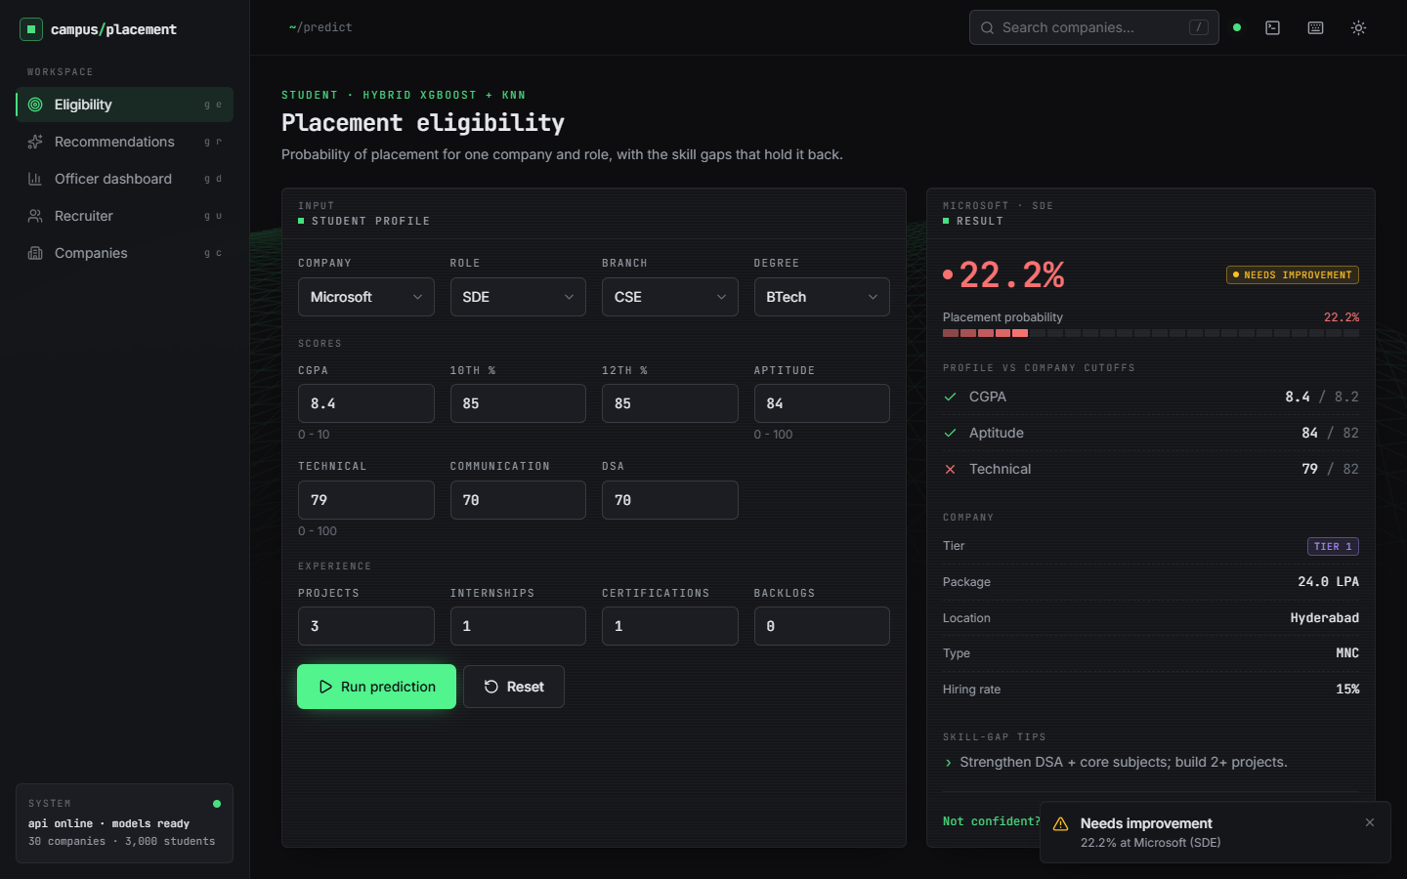  Figure 13: Eligibility screen with a real prediction (Microsoft, SDE). | 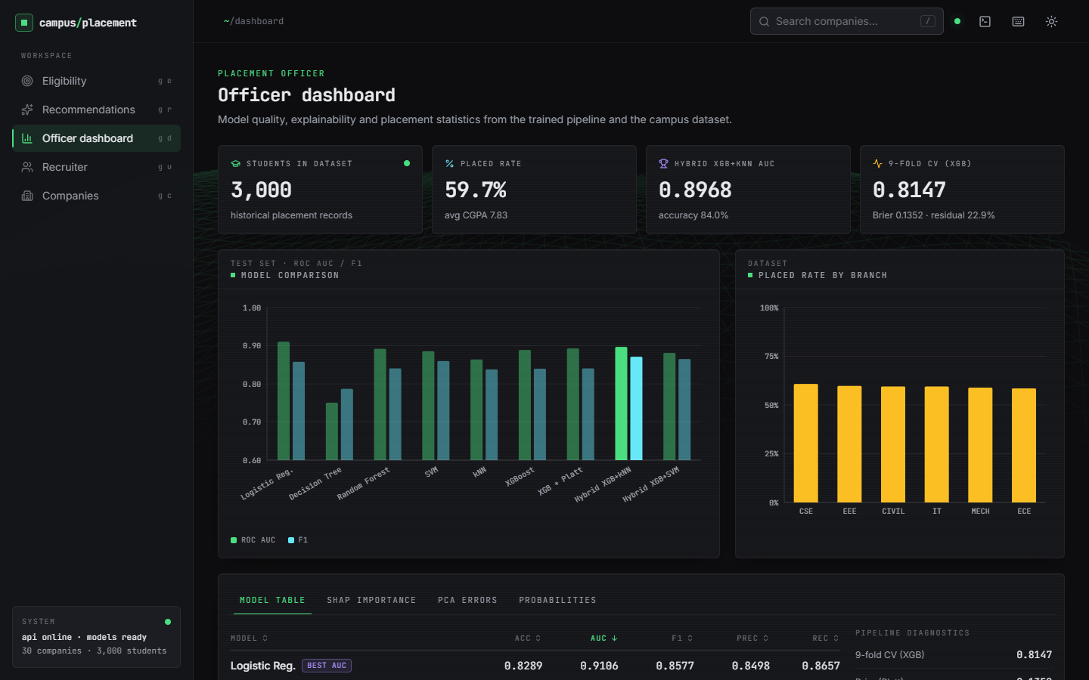  Figure 14: Officer dashboard overview.

2. IMPLEMENTATION

2.1 Application architecture
A request travels from the React page through the Vite proxy to FastAPI, which validates it and calls src/recommend.py. For every prediction predict_for calls load_artifacts(), which reads four pickle files (preprocessing, calibrated XGBoost, kNN and the company table) from disk, builds a one-row feature vector and returns the probability. The core of the function is:
def predict_for(profile, company_row, role):
pre, xgb, knn, comp = load_artifacts()
X = _row_features(profile, company_row, role, pre)
p = float(xgb.predict_proba(X)[0, 1])
# residual refinement: if borderline, blend with kNN (paper Fig.8)
if 0.4 <= p <= 0.6:
pk = float(knn.predict_proba(X)[0, 1])
p = 0.5 * p + 0.5 * pk
return round(p, 4)

Reloading the pickles on every call keeps the code simple and the server stateless, but it costs time: one prediction takes a mean of 66 ms over HTTP, and a recommendation, which calls predict_for once per feasible company and role (up to 4 x 30 times), takes a mean of 5.4 s. Caching the loaded artefacts in the module would remove most of this and is the first improvement listed in Chapter 10; it was not done because it changes the shared core code that the Flask interface also uses.
The skill-gap tips are produced in the API layer by _tips, which applies the same four rules as the Flask route:
def _tips(profile, row):
tips = []
if profile['cgpa'] < float(row['CGPA_Cutoff']):
tips.append('CGPA ... below <company> cutoff ... - target Tier-2/3 companies.')
if profile['aptitude'] < float(row['Apt_Cutoff']):
tips.append('Improve aptitude (target 75+) via weekly mock tests.')
if profile['technical'] < float(row['Tech_Cutoff']):
tips.append('Strengthen DSA + core subjects; build 2+ projects.')
if profile['internships'] == 0:
tips.append('Get at least 1 internship - strongly boosts probability.')
if not tips:
tips.append('Strong profile - apply and prepare for interviews.')
return tips

2.2 API design
The endpoint list is in Section 5.9. A prediction request and response look as follows (values from a real call with a strong CSE profile and target Infosys, role SDE; fields not shown are omitted):
POST /api/predict
{ "cgpa": 8.4, "tenth": 88, "twelfth": 86, "aptitude": 82, "technical": 84, "communication": 75,
"dsa": 80, "projects": 3, "internships": 1, "certifications": 2, "backlogs": 0,
"branch": "CSE", "degree": "BTech", "target_company": "Infosys", "target_role": "SDE" }

200 { "placement_probability": 0.9032, "eligible": true, "label": "PLACEMENT READY",
"company": "Infosys", "role": "SDE", "company_detail": { "Tier": 3, "CGPA_Cutoff": 6.0, ... },
"tips": ["Strong profile - apply and prepare for interviews."] }

POST /api/recommend returns base_prob, the three lists company_only, role_only and hybrid (each item has company, role, tier, package, location, prob, score and proximity), avg_gain and match_rate. POST /api/recruiter/shortlist filters the student table with the thresholds and returns total_matches and at most 50 rows; total_matches was added to the response of the Flask page so that the interface can say "1394 candidates match" while showing only the top 50. The React client keeps one axios instance with a 60 s timeout; an interceptor logs every call, its status and its duration to the activity log.

2.3 Security and error handling
Table 7: Input validation and errors
Situation | Behaviour | HTTP
Number outside its range (CGPA 14, aptitude -5, backlogs 99) | Pydantic rejects the request; the page shows the field message | 422
Text where a number is required | Rejected by Pydantic | 422
Missing required field (target_company) | Rejected by Pydantic | 422
Unknown company name | _company_row raises | 404
Unknown plot name or path-traversal text in the plot name | Only three names are allowed | 404
Model or data file missing | Clear message naming the command to run | 503
Model raises on unseen values | Caught and returned as Prediction failed: ... | 422
Foreign browser origin | No CORS header is returned | -

The security posture is that of a local teaching prototype, and the limits should be read plainly. There is no authentication and no authorisation: any client that can reach the port can read the student table through the shortlist endpoint, so the server must not be exposed to an untrusted network. There is no database, so SQL injection is not possible; a test with a SQL-injection string, a script tag, a path-traversal name and a 100 kB company name all returned 404 and nothing was executed (Chapter 7). There is no rate limiting, no HTTPS and no audit log. An unseen branch or role value is accepted and encoded with frequency 0 instead of being rejected. The pickled model files are loaded with pickle, which is safe only for files the operator trained; they must not be replaced by files from an untrusted source.

2.4 6.9A Front-end implementation
The React application rests on four shared pieces: api.js (axios client whose interceptors feed the activity log and turn failures into a message and a hint), lib/useFetch.js (data, error, loading and reload for every GET), lib/profile.js (field ranges, defaults and validation mirroring the server) and lib/theme.jsx (theme and colour tokens, so charts and the three.js backdrop re-tint). Pages are lazy-loaded; the Recruiter page sorts and pages the 50 returned rows in the browser and exports them as CSV, and the dashboard tabs show the PNG files served by /api/plots/{name}.

2.5 Installation and execution
Table 8: Software environment used for this work
Component | Version
Operating system / hardware | Windows 11 Pro; Intel Core i5-12500 (6 cores, 12 threads); 15.7 GB RAM; none (CPU only)
Python and packages | Python 3.14.7; scikit-learn 1.9.0; xgboost 3.4.1; pandas 3.0.5; numpy 2.5.3; shap 0.52.0
Back end | FastAPI 0.159.1; uvicorn 0.54.0; pydantic 2.14.1; Flask 3.1.3 (original interface)
Front end | Node 24.19.0; React 19.3; Vite 8.3; Tailwind 4.3; three.js 0.186; Recharts, framer-motion, GSAP

One-command start. Python 3.10 or newer and Node.js 20 or newer are required. Running run.bat in 8.ProjectCode (i) reads the ports from .env (backend 8405, frontend 5405), (ii) creates .venv and installs requirements.txt if the packages are missing, (iii) generates the data and trains the models only if models/xgb_calibrated.pkl is absent, (iv) runs npm install in frontend/ if needed, and (v) opens two windows, one for uvicorn backend.main:app --port 8405 and one for npm run dev, and the browser at http://localhost:5405.
python -m venv .venv
.venv\Scripts\python.exe -m pip install -r requirements.txt
.venv\Scripts\python.exe src\generate_dataset.py # data/*.csv
.venv\Scripts\python.exe src\preprocess.py # models/preprocess.pkl
.venv\Scripts\python.exe src\hybrid_model.py # models, metrics.json, plots
.venv\Scripts\python.exe -m uvicorn backend.main:app --port 8405
cd frontend && npm install && npm run dev # http://localhost:5405
python app.py # original Flask UI, port 5000

The checks are run with python scripts/smoke_test.py (15 checks against the running API) and python scripts/edge_tests.py (46 checks); python scripts/capture_screens.py records the screens with Playwright. Typical problems are a missing pyarrow (the pickled company table needs it under pandas 3; it is in requirements.txt), a port already in use (change .env) and "Could not reach the placement API" when the backend window is not running.
Implementation notes. The front end is built into code-split chunks (three.js, charts, motion and GSAP are separate bundles) with npm run build; npm run preview serves the build on 5405 with the same /api proxy. All ports come from .env, so the system can run beside other projects on the same PC.

3. KEY CODE WALK-THROUGHS
This section walks through the code that carries the design. The listings are copied from the repository.

3.1 Features: from a student record to 24 numbers
def build_features(df, comp, freq_maps=None, scaler_stats=None, fit=False):
m = df.merge(comp, left_on="Target_Company", right_on="Company", how="left")
out = df.copy()
out["Skill_Index"] = (0.4 * out["Technical_Score"] + 0.3 * out["Aptitude_Score"]
+ 0.15 * out["Communication_Score"] + 0.15 * out["DSA_Score"]) / 100.0
out["Company_Hiring_Rate"] = m["Hiring_Rate"].astype(float).values
out["CGPA_x_Tier"] = out["CGPA"] * out["Target_Tier"] # interaction like Program x QS Rank
out["CGPA_Gap"] = out["CGPA"] - m["CGPA_Cutoff"].astype(float).values
out["Apt_Gap"] = out["Aptitude_Score"] - m["Apt_Cutoff"].astype(float).values
out["Tech_Gap"] = out["Technical_Score"] - m["Tech_Cutoff"].astype(float).values

if fit:
freq_maps = {c: (out[c].value_counts(normalize=True).to_dict()) for c in FREQ_COLS}
scaler_stats = {}
for c in NUM_COLS + EXTRA_NUM:
mu, sd = out[c].mean(), out[c].std() + 1e-9
scaler_stats[c] = (mu, sd)

for c in FREQ_COLS:
mp = freq_maps[c]
out[c + "_freq"] = out[c].map(mp).fillna(0.0)

for c in NUM_COLS + EXTRA_NUM:
mu, sd = scaler_stats[c]
out[c + "_std"] = (out[c] - mu) / sd

feat = [c + "_std" for c in NUM_COLS + EXTRA_NUM] + [c + "_freq" for c in FREQ_COLS]
X = out[feat].values.astype(float)
return X, feat, freq_maps, scaler_stats

build_features joins the student rows with the company table on the target company, then derives six features. Skill_Index is a weighted mean of technical (0.4), aptitude (0.3), communication and DSA (0.15 each). CGPA_Gap, Apt_Gap and Tech_Gap are the student's score minus the company's cutoff, which makes the same student look different for different companies. When fit is true the function learns the frequency maps of the five categorical columns and the mean and standard deviation of 19 numeric columns; otherwise it applies the stored ones. Fitting on the training split only avoids leakage of the test distribution.

3.2 Calibration and the residual hybrid
calib = CalibratedClassifierCV(base_xgb, method="sigmoid", cv=3)
calib.fit(Xtr, ytr)
pxgb = calib.predict_proba(Xte)[:, 1]
pred_xgb = (pxgb >= 0.5).astype(int)
brier = float(brier_score_loss(yte, pxgb))
print(f"calibrated XGB brier={brier:.4f}")
results["xgb_calibrated"] = metrics(yte, pred_xgb, pxgb)

# --- hybrid residual refinement ---
# R = misclassified OR prob in [0.4, 0.6] (Eq.1 paper)
residual_mask = (pred_xgb != yte) | ((pxgb >= 0.4) & (pxgb <= 0.6))
print(f"residual rate on test: {residual_mask.mean():.3f}")

knn_res = KNeighborsClassifier(n_neighbors=9, weights="uniform")
knn_res.fit(Xtr, ytr) # local model trained globally, applied locally (paper Fig.8)
svm_res = SVC(kernel="rbf", probability=True, random_state=SEED)
svm_res.fit(Xtr, ytr)

def hybrid(pred_base, prob_base, local_pred):
out = pred_base.copy()
out[residual_mask] = local_pred[residual_mask]
# for AUC use blended prob: keep base prob except residuals use local prob
return out

pknn = knn_res.predict(Xte)
psvm = svm_res.predict(Xte)
prob_knn = knn_res.predict_proba(Xte)[:, 1]
prob_svm = svm_res.predict_proba(Xte)[:, 1]
hybrid_knn = hybrid(pred_xgb, pxgb, pknn)
hybrid_svm = hybrid(pred_xgb, pxgb, psvm)
hprob_knn = pxgb.copy(); hprob_knn[residual_mask] = prob_knn[residual_mask]
hprob_svm = pxgb.copy(); hprob_svm[residual_mask] = prob_svm[residual_mask]
results["hybrid_xgb_knn"] = metrics(yte, hybrid_knn, hprob_knn)

XGBoost is wrapped in CalibratedClassifierCV with the sigmoid (Platt) method and three folds. The residual mask is the union of the rows that the calibrated model gets wrong and the rows whose probability is between 0.4 and 0.6. The expression pred_xgb != yte uses the test labels, which is why this version of the hybrid cannot be applied to a new student (Chapter 8). The kNN and SVM local models are fitted on the whole training set and applied to the masked rows only.

3.3 The serving rule
def predict_for(profile, company_row, role):
pre, xgb, knn, comp = load_artifacts()
X = _row_features(profile, company_row, role, pre)
p = float(xgb.predict_proba(X)[0, 1])
# residual refinement: if borderline, blend with kNN (paper Fig.8)
if 0.4 <= p <= 0.6:
pk = float(knn.predict_proba(X)[0, 1])
p = 0.5 * p + 0.5 * pk
return round(p, 4)

This is what the running system does. It loads the artefacts, builds the feature row, and takes the calibrated probability. Only if the probability is in the band 0.4 to 0.6 does it average it with the kNN probability. The rule uses no label. Note that load_artifacts() reads four pickle files on every call, which is the source of the latency reported in Chapter 7.

3.4 Feasibility filters and scoring in the recommendation module
# --- feasibility filters (paper Sec 3.11) ---
gap = abs(profile["cgpa"] - row["CGPA_Cutoff"])
if gap > delta_max_cgpa(row["Tier"]):
continue
if profile["aptitude"] < row["Apt_Cutoff"] - 15:
continue
if profile.get("backlogs", 0) > 2 and row["Tier"] == 1:
continue
if min_package and row["Package_LPA"] < min_package:
continue
prox = max(0.0, 1 - gap / delta_max_cgpa(row["Tier"])) # GPA_Proximity Eq.
roles = list(dict.fromkeys([base_role, "SDE", "Data Analyst", "QA Engineer"]))
for role in roles:
try:
p = predict_for(profile, row, role)
except Exception:
continue
loc_bonus = 0.02 if (prefer_location and row["Location"] == prefer_location) else 0.0
score = p + 0.05 * prox + loc_bonus
cands.append({"company": row["Company"], "role": role, "tier": int(row["Tier"]),
"package": float(row["Package_LPA"]), "location": row["Location"],
"prob": p, "score": round(score, 4), "proximity": round(prox, 3)})

A company is a candidate only if the student's CGPA is within the tier tolerance of the cutoff, the aptitude score is at most 15 points below the cutoff, the student is not a Tier-1 candidate with more than two backlogs, and the package is high enough. For each surviving company the module scores up to four roles. The score is the probability plus 0.05 times the CGPA proximity plus a 0.02 bonus for the preferred location. Because the probability dominates, the easiest companies tend to win for weak profiles.

3.5 The prediction endpoint
def predict(body: PredictIn):
row = _company_row(body.target_company)
profile = body.model_dump(exclude={"target_company", "target_role"})
profile.update(stype="Regular", year=2026)
try:
p = predict_for(profile, row, body.target_role)
except Exception as e: # the model code raises plain exceptions for unseen values
raise HTTPException(422, f"Prediction failed: {e}")
return {"placement_probability": p, "eligible": bool(p >= 0.5),
"label": "PLACEMENT READY" if p >= 0.5 else "NEEDS IMPROVEMENT",
"company": row["Company"], "role": body.target_role,
"company_detail": json.loads(row.to_json()), "tips": _tips(profile, row)}

The endpoint looks the company up (404 if unknown), dumps the validated profile, calls predict_for and returns the probability, the label, the company row and the tips. Pydantic has already enforced the ranges (422); an exception raised inside the model code (for example from an unseen value) becomes a 422 with the message.

4. IMPLEMENTATION DECISIONS AND THEIR REASONS
Each decision below is stated with the alternative that was available and the reason for the choice.
Table 9: Implementation decisions
Decision | Alternative | Reason
Add a FastAPI layer that imports src/recommend.py unchanged | Rewrite the model code inside the API | One code path: the Flask and React applications cannot disagree; the modelling code kept its tests and metrics
Frequency encoding of categorical columns | One-hot encoding | As in the base paper [2]; avoids 30 company columns and keeps the feature count at 24. Costs: unseen categories get 0 silently (L8)
Standardise numeric features, fitted on the training split | Leave raw | Required for kNN and SVM and harmless for trees; fitting on training data avoids leakage
Company-specific gap features | Raw scores only | A score of 79 is good for one company and bad for another; the gap features are the top-ranked ones by SHAP
XGBoost as the main model, with Platt scaling | Logistic Regression, which was the best by AUC | Follows the base paper and gives a non-linear model that would matter on real data; the choice is not supported by this synthetic data (Chapter 8)
Decision threshold 0.5 | Tune on the validation set | Accuracy is flat from 0.30 to 0.70; 0.5 is conventional and simple to explain
Residual band 0.4 to 0.6 with a 50/50 blend at serving time | The paper's label-based rule | The label-based rule cannot run on a new student; the blend is a soft, label-free substitute whose effect is negligible
Load pickles on every call | Cache the artefacts in memory | Simplicity of the original code; accepted at documentation time, flagged as limitation L9
CSV and pickle files, no database | MySQL named in the batch description | Nothing in the system needs queries, updates or concurrency; one fewer dependency
React with Vite, Tailwind, Recharts and a three.js backdrop | Server-rendered Flask templates | Interactive charts, tables and a command palette; the original Flask interface was kept as the reference
CORS restricted to ports 5405 on localhost | Allow all origins | Smallest exposure for a single-machine application; checked by tests S5 and S6
Synthetic data from a logistic label model | Search for public placement data | No real placement data was available; the generator is reproducible with seed 42; the consequence is stated everywhere (L1, L2)

